Assignment no 4
1) Write a select command that produces the order number, amount, and date for all
rows in the Orders table.
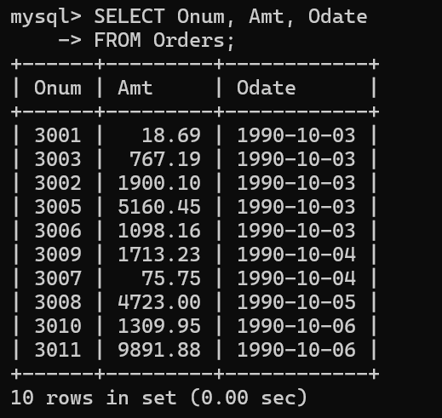
2) Write a query that produces all rows from the Customers table for which the
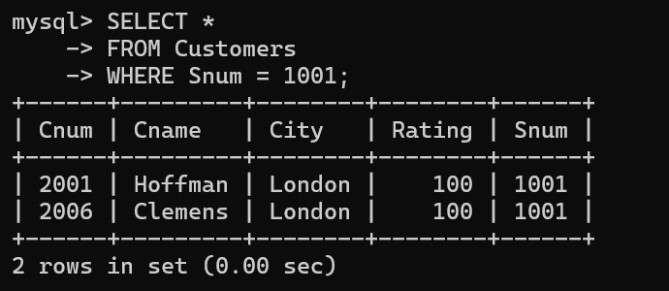
salesperson’s number is 1001.
3) Write a query that displays the Salespeople table with the columns in the
following order: city, sname, snum, comm.
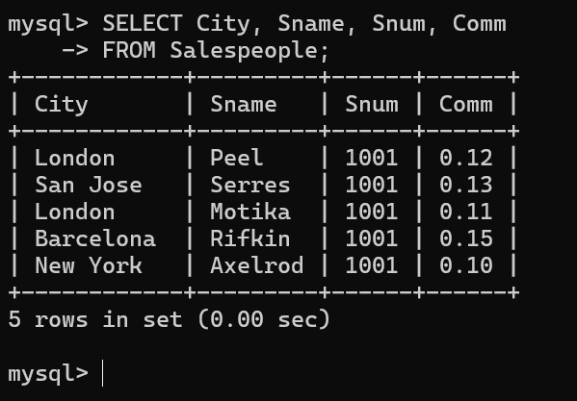
4) Write a select command that produces the rating followed by the name of each
customer in San Jose.
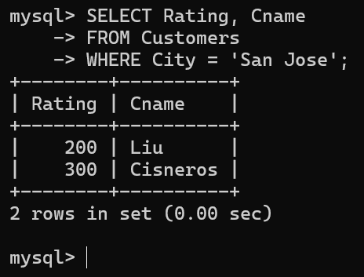
5) Write a query that will produce the snum values of all salespeople (suppress the
duplicates) with orders in the Orders table.

